Leetcode question
Count the Digits That Divide a Number - LeetCode
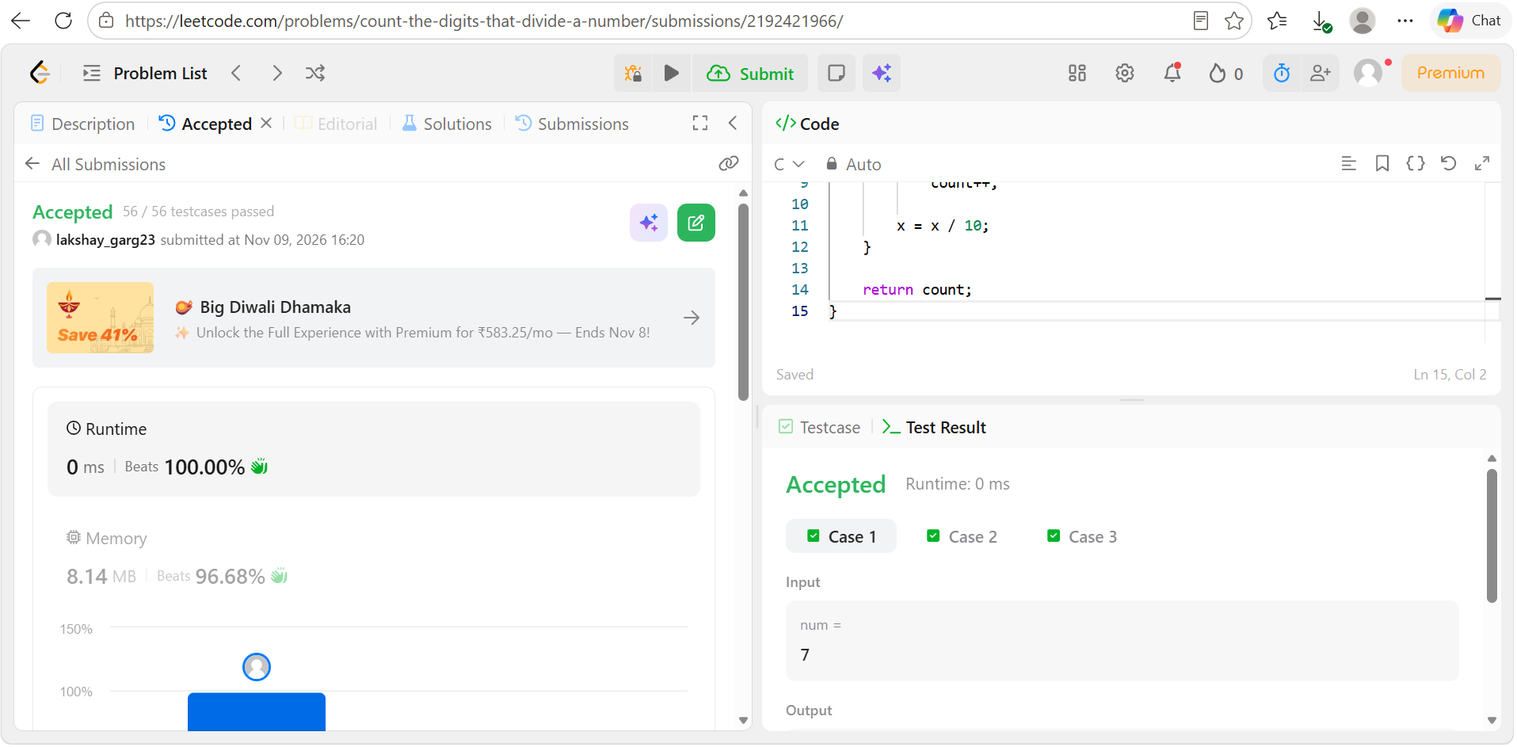
Code
int countDigits(int num) {
int x = num;
int count = 0;

while (x > 0) {
int digit = x % 10;

if (digit != 0 && num % digit == 0)
count++;

x = x / 10;
}

return count;
}

